|  |  |  |  |
| --- | --- | --- | --- |
| **CMIF Risk Management Plan Template** | | | |
| **Applicant Information** | | | |
| Primary Contact Name |  | Project Name |  |

**Instructions:**

Please provide the following information for each type of risk in the tables below:

**Risk statement and description:** Provide a statement that summarizes the risk and give a detailed but concise description of the risk. Outline why this risk was identified or may occur.

**Likelihood and severity:** Provide the probability of the risk materializing and the expected severity of the risk’s impact, using a high/medium/low scale for each. Provide a brief description to support these assessments.

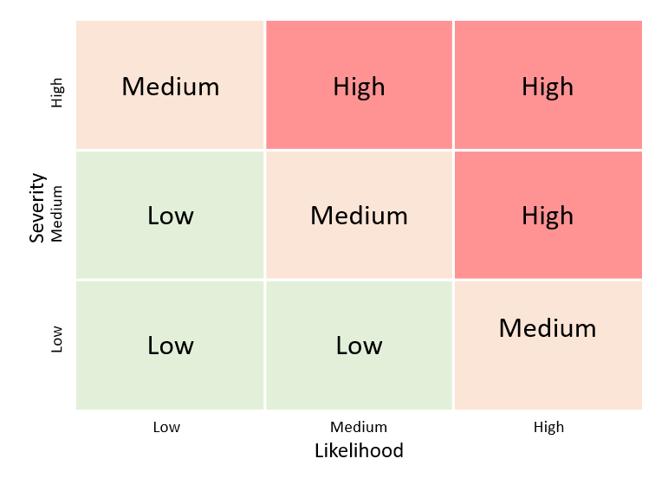

**Figure 1: Risk conversion**

**Initial risk level:** Using Figure 1, identify the overall risk (low, medium, or high) based on the level of expected probability (likelihood) and severity of impact.

**Proposed mitigation:** Outline the detailed, concrete proposed response to the risk (for example, mitigate, transfer, accept).

**Residual risk level:** Identify if the post-mitigation risk is low, medium, or high.

Include each point of information in the above descriptions in the bottom box of the column for each table under of its respective title. Be sure to closely examine each risk category (financial, legal, environmental, etc.) as it pertains to your project. If there are multiple risks for the same risk category (e.g., caribou habitat and peatlands disruption under environmental risks), add rows as needed. For the risk categories that have no identified risks associated with them, fill in the box N/A.

|  |  |  |  |  |
| --- | --- | --- | --- | --- |
| **1) Financial Risks** –Describe any potential financial risks to your project. Consider access to credit to facilities, debt accumulation, sources of cash flow, etc. | | | | |
| **Risk statement and description** | **Likelihood and severity** | **Initial risk level** | **Proposed mitigation** | **Residual risk level** |
|  |  |  |  |  |

|  |  |  |  |  |
| --- | --- | --- | --- | --- |
| **2) Technological Risks** –Describe any potential risks related to the technology utilized in your project, including the maturity and feasibility of the technology. Consider the availability of technical expertise, a talent pipeline of suitably qualified personnel to be assigned to the project, access to equipment, etc. | | | | |
| **Risk statement and description** | **Likelihood and severity** | **Initial risk level** | **Proposed mitigation** | **Residual risk level** |
|  |  |  |  |  |

|  |  |  |  |  |
| --- | --- | --- | --- | --- |
| **3) Managerial Risks** –Describe any potential managerial risks to your project. Consider your organization's expertise, past experience in the project area, background, current workforce, etc. | | | | |
| **Risk statement and description** | **Likelihood and severity** | **Initial risk level** | **Proposed mitigation** | **Residual risk level** |
|  |  |  |  |  |

|  |  |  |  |  |
| --- | --- | --- | --- | --- |
| **4) Project Feasibility Risks** –Describe any potential risks to the feasibility of your project including supply chain constraints, project scheduling, costs tracking, project monitoring, reporting, etc. | | | | |
| **Risk statement and description** | **Likelihood and severity** | **Initial risk level** | **Proposed mitigation** | **Residual risk level** |
|  |  |  |  |  |

|  |  |  |  |  |
| --- | --- | --- | --- | --- |
| **5) Legal Risks** –Describe any potential legal risks to your project. Include any current or potential litigation against your organization that may impact delivery of the project and any current or potential litigation against the proposed project that would impact its delivery. | | | | |
| **Risk statement and description** | **Likelihood and severity** | **Initial risk level** | **Proposed mitigation** | **Residual risk level** |
|  |  |  |  |  |

|  |  |  |  |  |
| --- | --- | --- | --- | --- |
| **6) Environmental Risks** –Describe any potential environmental risks to your project. Include potential species impacted, ground water contamination, threats to biodiversity, net increases to C02 emissions, peatlands disturbed, etc. These may be high-level summaries of risks identified as part of an environmental or impact assessment. | | | | |
| **Risk statement and description** | **Likelihood and severity** | **Initial risk level** | **Proposed mitigation** | **Residual risk level** |
|  |  |  |  |  |

|  |  |  |  |  |
| --- | --- | --- | --- | --- |
| **7) Social Risks** – Describe any potential social risks to your project. Include the degree of support for the project demonstrated by local communities, stakeholders, and governments. Include any details about how lack of community support for the proposed project might impact its delivery. | | | | |
| **Risk statement and description** | **Likelihood and severity** | **Initial risk level** | **Proposed mitigation** | **Residual risk level** |
|  |  |  |  |  |

|  |  |  |  |  |
| --- | --- | --- | --- | --- |
| **8) Cybersecurity Risks (Energy Projects Only)** –Describe any potential cybersecurity risks to your project. Include the controls, standards, tools, and practices that may be implemented to protect the energy infrastructure from cybersecurity incidents. For non-energy projects, type N/A. | | | | |
| **Risk statement and description** | **Likelihood and severity** | **Initial risk level** | **Proposed mitigation** | **Residual risk level** |
|  |  |  |  |  |

|  |  |  |  |  |
| --- | --- | --- | --- | --- |
| **9) Other Risks** –Describe any other risks to your project that are not addressed in the categories above. | | | | |
| **Risk statement and description** | **Likelihood and severity** | **Initial risk level** | **Proposed mitigation** | **Residual risk level** |
|  |  |  |  |  |